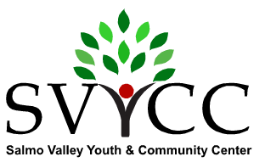
On V. List _______ NfP. _______
Box 498, 206 - 7th Street, Salmo, BC V0G 1Z0 250-357-2320

Salmo River Valley Fall Festival - Craft Faire 2016
Not-For-Profit Application for Vending on September 30th , 2017
(completed application can be scanned and emailed to: laurie@svycc.ca)

Vendor Name: __________________________________________________________________
Contact Name: _________________________________________________________________
Mailing Address: (incl. postal code): ________________________________________________
Telephone: ___________________________________
Email: _______________________________________
Please give a brief description of what you wish to display and/or sell: ____________________________________________________________________________________
____________________________________________________________________________________
____________________________________________________________________________________
Not For Profit organizations vend free of charge.

In the gymnasium, ONE ‘SPACE’ = ONE 6 ft by 3 ft TABLE. Spaces ‘shared’ = ½ space. See pricing below.

Please indicate your needs:

# of full spaces: ______ ½ spaces? ______ Power? _____ Wall space? _____

Use own table/s #? ______

Do you have your own table/s #? ___________ . Would your organization share a table? _____

Wall space and power outlets are limited. Please apply early.

Spaces are available outdoors. Vendors must provide their own tables/tents.

The Craft Faire will take place between the hours of 9:00 a.m. and 3:00 p.m. Vendors may set up from 7:00 a.m. to 9:00 a.m., or the evening before by special request to the Management.

I understand that Craft Faire Management may refuse entry to any not-for-profit vendor at their discretion. I have received and read a copy of the Rules and Regulations of the Salmo River Fall Festival Craft Faire and acknowledge that I understand them and agree to abide by them.

Signature of Organization Representative: ______________________________________

