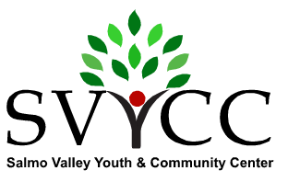
Amt. Paid: $_______ Cash___ or Cheq #_____
Recorded on Vendor List: ______
Box 498, 206 - 7th Street, Salmo, BC V0G 1Z0 250-357-2320

Salmo River Valley Fall Festival - Craft Faire 2017
Application: For Profit Vending on September 30th, 2017
(Completed application can be scanned and emailed to: laurie@svycc.ca )

Vendor Name: __________________________________________________________________
Business Name: _________________________________________________________________
Mailing Address: (incl. postal code): ________________________________________________
Telephone: ___________________ Email: _______________________________________
Please give a brief description of your products: ___________________________________________________
_________________________________________________________________________________________________
_________________________________________________________________________________________________
In the gymnasium, ONE ‘SPACE’ = ONE 6 ft by 3 ft TABLE. Spaces ‘shared’ = ½ space. See pricing below.
Please indicate your needs: # of Spaces - full: ________ half: ________ Power? ______ Wall space? ______
Use own table/s #?__________

Wall space and power outlets are limited. Please apply early.
I have received and read a copy of the Rules and Regulations of the Salmo River Valley Fall Festival and Craft Faire and acknowledge that I understand them and agree to abide by them.
Signature: ___________________________________________ Date: ____________________________

RECEIPT
Vendor: _____________________________ No. of spaces rented: full _____; half _____ Amt. paid: $___________
COST: $25 per space; $20 for 2nd & 3rd spaces; $15 if providing own table/s; $12.50 for half space. The Craft Faire will take place between the hours of 9:00 a.m. and 3:00 p.m. Vendors may set up from 7:00 a.m. to 9:00 a.m., or the evening before by special request to the Management. Vendor applications and payment are required by October, 2017.

Please make cheques payable to: Salmo Valley Youth & Community Centre. Electronic Transfers accepted.
Deliver to: 206 – 7th Avenue, Salmo, B.C. or mail to: SVYCC, Craft Faire, Box 498, Salmo BC V0G 1Z0

Signature of Craft Faire Coordinator, upon payment: ___________________________________________

